# App Icon – Loading Page – Tab 1

App logo (blue / green background)

App Name: PremiumGrocerLocator

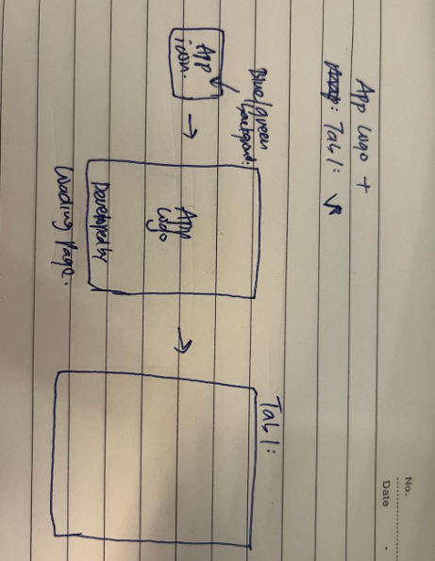

# Tab 1: Map page

Users will see the map page when they launch the application. The mobile application will ask the user to grant the necessary permissions to determine their current location for the first time. The user must accept the request to display nearby supermarkets on the map.

Supermarkets to use: FairPrice Finest, FairPrice, Sheng Shiong, Cold Storage, Culina, Scoop Wholefoods

|  |  |  |
| --- | --- | --- |
| **No.** | **Test Case Description** | **Expected Result** |
| 1 | Launch PremiumGrocerLocator for the first time after installation | Request precise location permission popup |
| 2 | Deny location permission in the popup | Map in map page will not be loaded |
| 3 | After 1, Launch PremiumGrocerLocator | Shows the map and the user's current location |
| 4 | Verify that nearby markets are displayed | Nearby markets should be displayed with red marker icons |
| 5 | Click on an icon on the top right . | The map zooms into the user's current location and shows nearby markets |
| 6 | Click on a nearby market | The market name, address, and operating hours should be displayed  FairPrice Finest  Seletar Mall (address)  7am – 11pm |

# Tab 2: Grocery list page

Category: Meat and Seafood, Fruits and Vegetables, Dairy, Food Cupboard, Baby and Child

List of Meat and Seafood items :

List of fruits and vegetables (organic / premium)

List of dairy (greek yoghurt brands)

List of food cupboard (nuts , chocolates)

List of milk powder (premium)

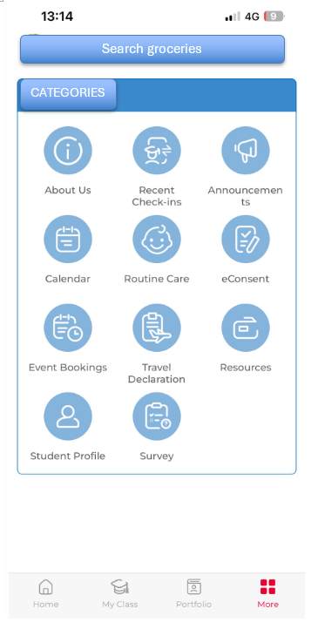 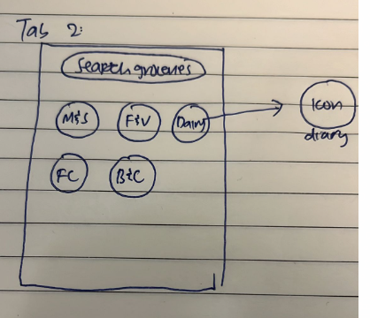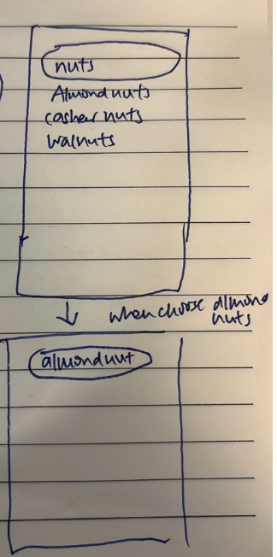

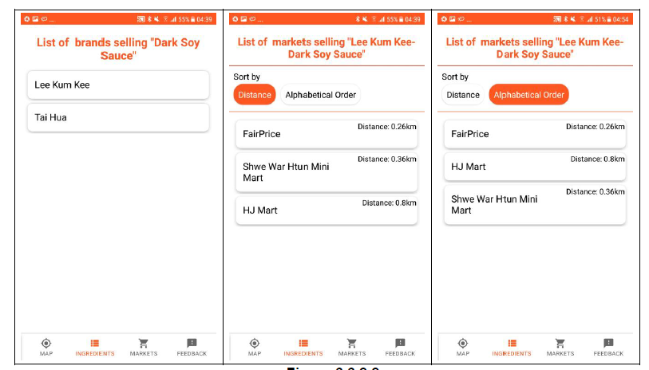

|  |  |  |
| --- | --- | --- |
| **No.** | **Test Case Description** | **Expected Result** |
| 1 | Click on the ingredient list tab at the bottom navigation bar | Display search bar and categories |
| 2 | Type in the grocery name in the search bar | The search results should display the grocery that matches the search query. |
| 3 | Click on the grocery from the list | Display a list of brands associated with the selected grocery |
| 4 | Click on the grocery brand from the brand page | Display a list of markets selling the selected brand-specified grocery |
| 5 | Check how the markets selling the brand-specified grocery are sorted | Markets should be displayed in the order of distance from the user's current location |
| 6 | Click on the filter function to sort markets alphabetically | Markets should be displayed in alphabetical order |
| 7 | After 1, click the categories | All the groceries under the categories should be listed out for the customers to scroll |

# Tab 3: Market list page

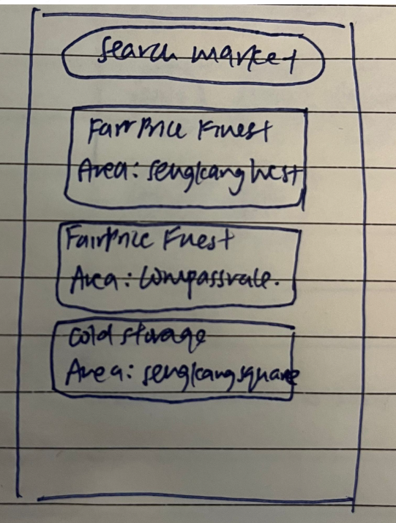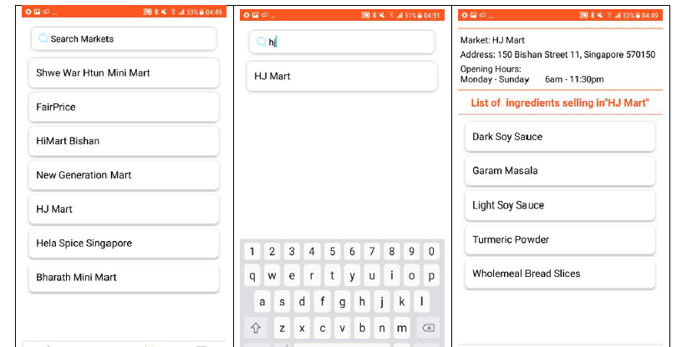

|  |  |  |
| --- | --- | --- |
| **No** | **Test Case Description** | **Expected Result** |
| 1 | Click on the markets list tab at the bottom navigation bar | Display a scrollable list of markets with a search bar |
| 2 | Type in a market name in the search bar | The search results should display markets that match the search query. |
| 3 | Click on a market from the list | Display the market name, address, and operating hours, together with a list of ingredients sold in that market |

# Tab 4: Feedback page

Issue: Store name / Groceries / Feedback (FIlter)

→ Store name → Description box : Please provide name address and contact number.

→ Groceries → Description box : Please provide name of item , brand, and where you see it (if applicable)

→ Feedback → Description box: General feedback (if any)

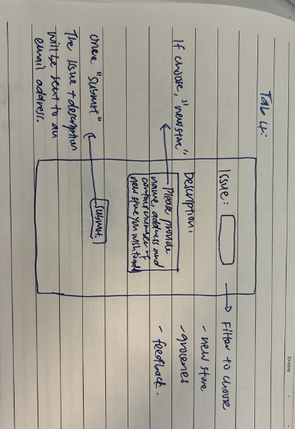

Once press submit, will send the issue type and description to email address of admin account : [webbyproject2024@gmail.com](mailto:webbyproject2024@gmail.com)

|  |  |  |
| --- | --- | --- |
| **No.** | **Test Case Description** | **Expected Result** |
| 1 | Click on the feedback tab at the bottom navigation bar | Display a feedback page with issue filter , description box |
| 2 | Leave fields blank and click on submit | A red exclamation mark with a message stating "required" appears at the end of the empty field(s) |
| 3 | Fill in all details and click submit | Email sent to [webbyproject2024@gmail.com](mailto:projectpgl2024@gmail.com) with issue type and description |